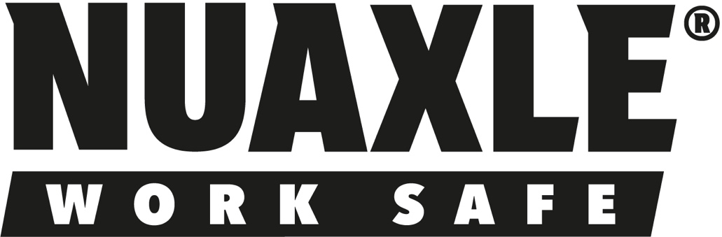

PHASE 1 – Launch & Revenue Generation

Public Website
- Homepage
- Shop
- Product Detail Pages
- About Us
- Contact Us
- Gallery
- News & Blog
- Become A Distributor
- Trade Account Application
- Warranty Registration
- How To Fit
- FAQ
- Affiliate & Ambassador Programme

Affiliate & Ambassador Programme (GoAffPro)

User Types
Influencers
- Automotive creators
- TikTok creators
- YouTube reviewers
- Industry influencers
Trade Ambassadors
- Mobile mechanics
- Wheel refurbishment companies
- Workshop owners
- Trainers & lecturers
- Fleet consultants
Sales Ambassadors
- Individuals visiting garages
- Independent sales reps
- Existing industry contacts

GoAffPro Functions
- Registration Form
- Approval Workflow
- Referral Links
- Discount Codes
- Commission Tracking
- Dashboard
- Marketing Asset Library
- Leaderboard
- Automated Payout Reporting

Additional NuAxle Requirements
Application Form should capture:
- Name
- Company
- Mobile
- Email
- Website
- Social Media Links
- Territory
- Type
  - Influencer
  - Workshop
  - Mobile Mechanic
  - Sales Ambassador
  - Training Centre
  - Distributor Referral Partner

Marketing Asset Library
Provide downloadable:
- Product Images
- Product Videos
- Installation Videos
- Social Media Posts
- Flyers
- Logos
- Brand Guidelines

PHASE 2 – Scale & Distribution
- Distributor Portal
- Fleet Solutions
- Education & Training Centres
- Customer Account Area
- Serial Number Database
- MRPeasy Integration
- CRM Integration
- Certification & Testing Centre
- Investor & Strategic Partner Page

One thing I’d add immediately
On the homepage and menu:
Become a Partner
This page then gives 3 options:
- Distributor
- Trade Account
- Affiliate & Ambassador Programme
That structure is much clearer than having separate menu items everywhere and mirrors the way people naturally think about working with NuAxle.

